**Day 7**

1. Rank employees by their total sales

(Total sales = Total no of orders handled, JOIN employees and orders table)

**Query:**

SELECT

e.employee_id,COUNT(o.order_id) AS total_sales,

RANK() OVER(ORDER BY COUNT(o.order_id) DESC) AS sales_rank

FROM employees e

INNER JOIN orders o

ON e.employee_id = o.employee_id

GROUP BY e.employee_id

ORDER BY total_sales DESC

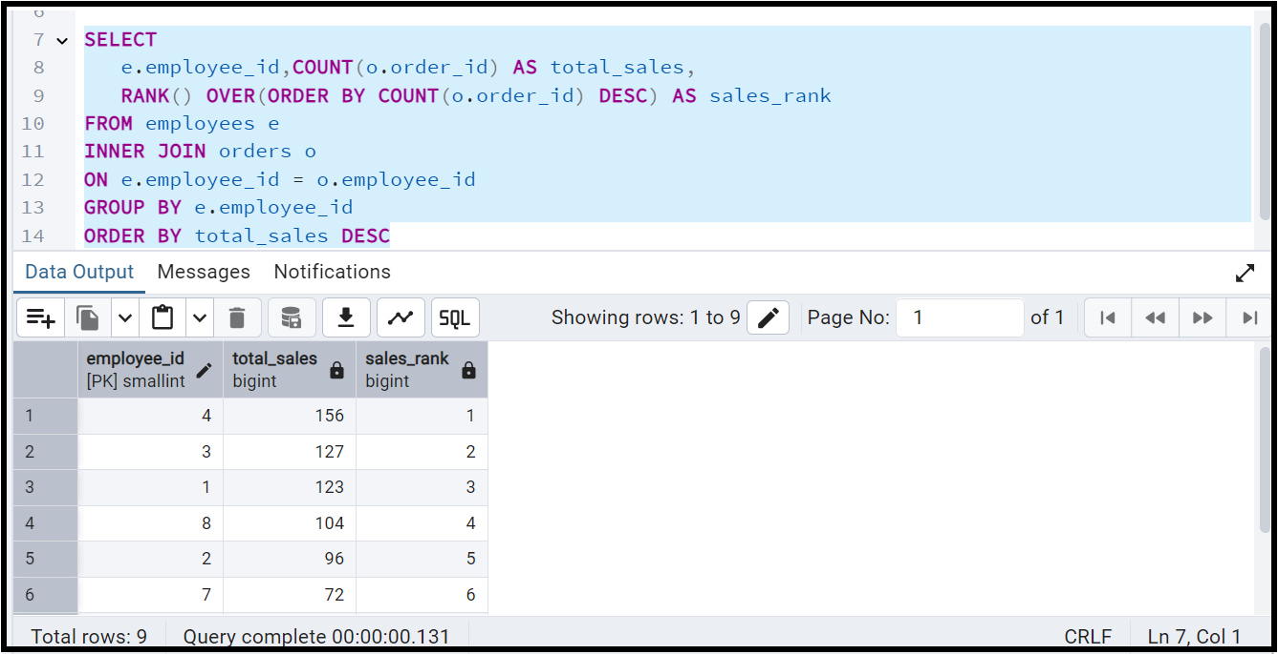

2. Compare current order's freight with previous and next order for each customer.

(Display order_id, customer_id, order_date, freight,

Use lead(freight) and lag(freight).

**Query:**

SELECT

order_id,customer_id,order_date,freight,

LEAD(freight) OVER(PARTITION BY customer_id ORDER BY order_date) AS next_freight,

LAG(freight) OVER(PARTITION BY customer_id ORDER BY order_date) AS previous_freight

FROM orders;

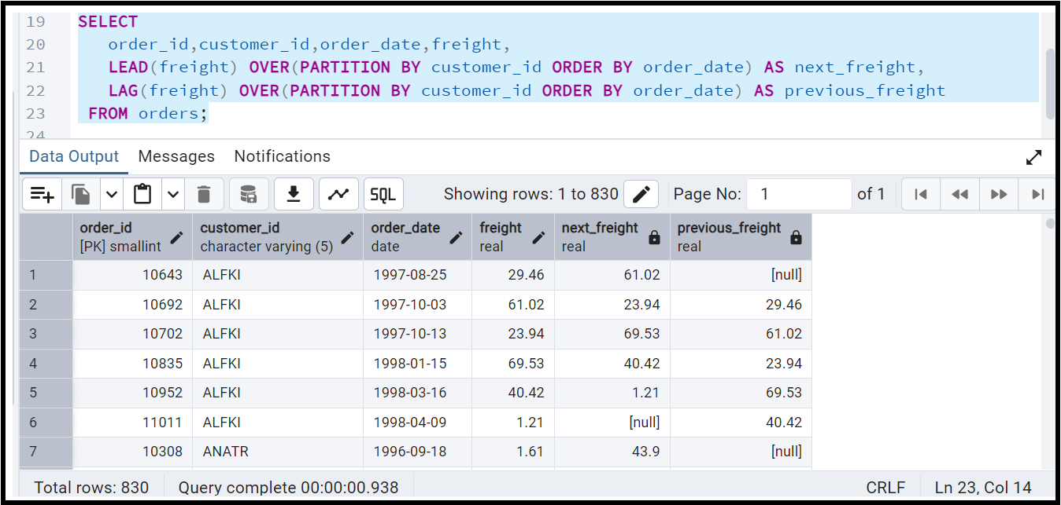

3. Show products and their price categories, product count in each category, avg price:

(HINT: Create a CTE which should have price_category definition:

WHEN unit_price < 20 THEN 'Low Price'

WHEN unit_price < 50 THEN 'Medium Price'

ELSE 'High Price'

In the main query display: price_category, product_count in each price_category, ROUND(AVG(unit_price)::numeric, 2) as avg_price)

**Query**:

WITH CTE1 AS(

SELECT

product_id,

product_name,

unit_price,

CASE

WHEN unit_price < 20 THEN 'Low Price'

WHEN unit_price < 50 THEN 'Medium Price'

ELSE 'High Price'

END AS price_category

FROM products

)

SELECT price_category,

ROUND(AVG(unit_price)::numeric, 2) AS avg_price,

Count(product_id) AS product_count

from CTE1

GROUP BY price_category

ORDER BY avg_price;

